|  |
| --- |
| Bravocareers.com |
| Project Handbook |
| Mobile Friendly Bravo Consulting Website |

|  |
| --- |
| [Author name]  30361543 Ajit Kunwar - Scrum Master  30361559 Birendra Rokaha - Product Manager  30323980 Petar Petrov - Development Team  30347752 Sushant Adhikari - Development Team  Ver 1.01 |

Table of Contents

**Revision** 2

**Preface** 2

**1.** **Introduction** 2

1.11 Project Overview 2

1.12 Project Deliverables 2

**2.** **Organization and processes** 3

2.1 Process model 3

2.2 Organizational structure and project responsibilities 4

2.3 Technical tools 4

Project management tools 4

Documentation tools 4

Communication tools 4

Development tools 4

2.4 Meetings 5

**3.** **Managerial process** 5

3.1 Management Objectives and Priorities 5

3.2Assumptions and dependencies 5

**4.** **Non-functional Requirements** 6

4.1 Platform 6

4.2 Communication 6

4.3 Performance 6

4.4 Security and Privacy 6

4.5 Audience 6

4.6 Reliability 6

4.7 Modifiability 6

4.8 Economic 6

4.9 Legal 7

4.10 Standards 7

4.11 Sitemap 7

**5.** **System Design** 8

5.1Design philosophy and goals 8

5.2 Screenshots 8

# **Revision**

|  |  |  |  |
| --- | --- | --- | --- |
| Version Number | Date approved | Approved by | Description |
| 1.01 | 01/09/2019 | Project Manager | Foundational planning and documentation of entire project |

# **Preface**

The purpose of this handbook is to show the initial process of the project by describing the project scope, deliverables, functionalities, technologies and management. As the audience of the document has been defined, the team members, the client and the supervisors.

# **Introduction**

## 1.11 Project Overview

In this project, we are assigned by the client to reengineer the Bravo Consulting website and more specifically, to improve its mobile responsiveness. The website is already up and running, however, the management is not happy with the look and feel of the website. The client is looking for a website that has a uniform look in both desktop and mobile devices. Our team will be analysing the website from top to bottom and fill up the missing gaps and undesirable design aesthetics. We will be using the latest web technologies available to make sure that the website is up to date and performs well in all browsers and devices. Also, we are going to implement authentication and location services to improve the User Experience.

**Deadlines**: 30/07/2020

**Budget**: 4*175=700$

## 1.12 Project Deliverables

|  |  |
| --- | --- |
| Deliverable | Approximate date |
| Project brief | 26 September 2019 |
| Initial product backlog | 11 August 2019 |
| Functional requirements analysis | 11 August 2019 |
| Project handbook | 1 September 2019 |
| Iteration/Sprint documentation | 1 September 2019 |
| Development demonstration | 6 September 2019 |
| Development demonstration 2 | 27 September 2019 |
| Iteration/Sprint documentation 2 | 29 September 2019 |
| Individual Interview | 3 October 2019 |
| Product Prototype | 4 October 2019 |

# **Organization and processes**

## Process model

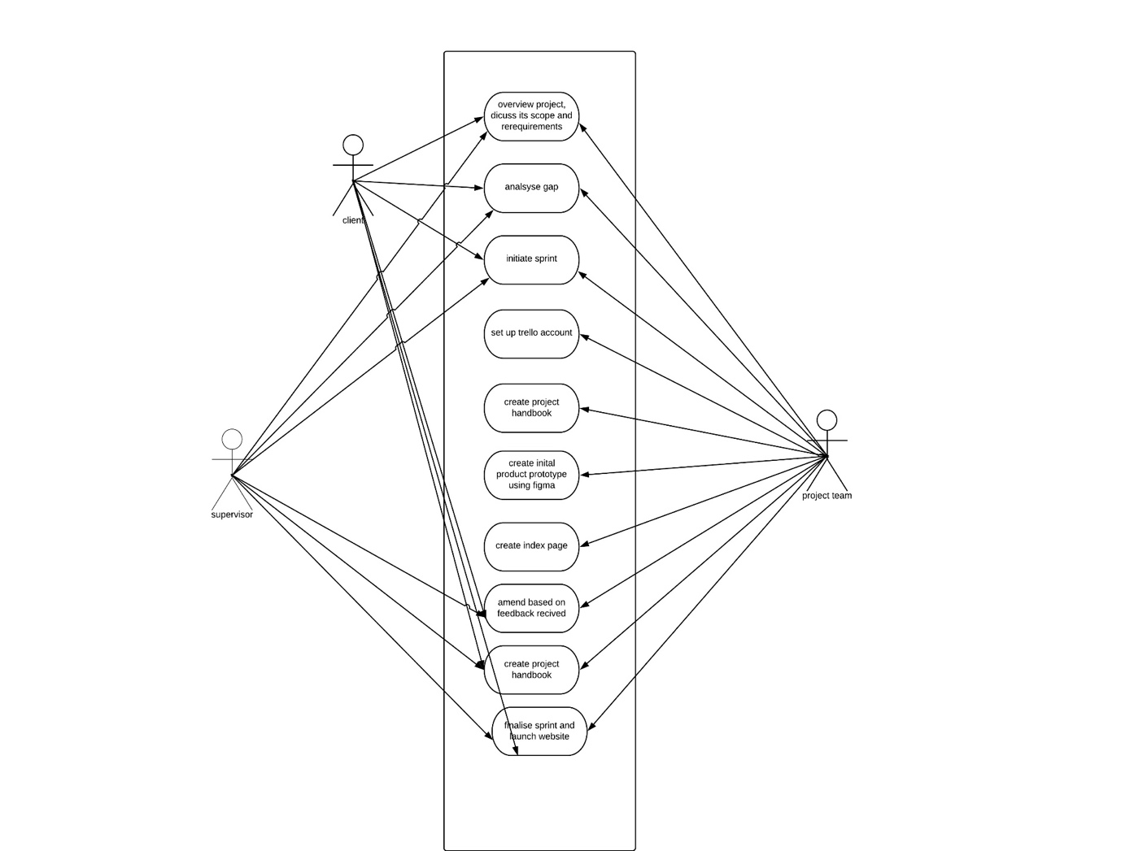

## 2.2 Organizational structure and project responsibilities

|  |  |  |
| --- | --- | --- |
| **Name** | **Tittle** | **Responsibilities** |
| Birendra Rokaha | Project Manager (Managerial role) | Communicate with supervisor and team members  Initiate sprint  Create index page  Review handbook  Review prototype  Amend based on feedback received  Finalize sprint |
| Petar Petrov | Scrum member  (Design & Development) | Set up a Trello account  Create activity logs in Trello  Create initial product prototype using Figma  Review handbook  Review index page  Amend based on feedback received |
| Sushant Adhikari | Scrum member (Documentation and Review) | Create project handbook  Review prototype  Review index page  Amend based on feedback received |
| Ajit Kunwar | Scrum Master (Documentation and Client communication) | Create project handbook  Review prototype  Review index page  Amend based on feedback received |

## 2.3 Technical tools

### Project management tools

* Trello
* Monday.com

### Documentation tools

* Microsoft word
* Draw.io

### Communication tools

* Facebook messenger
* Gmail

### Development tools

* Google Chrome browser
* Figma prototyping software
* Visual studio code

## 2.4 Meetings

|  |  |  |
| --- | --- | --- |
| Person | Location | Time and Day |
| Dayse Jourdan | 16/233 cardigan St.,  Carlton | 4:30 – 5:30 pm every Friday |
| Krishna Poudel | Room 501 MIT | 1:30 – 2:30 pm every Tuesday |

# **Managerial process**

## Management Objectives and Priorities

• Focus on the client’s requirements first: We as a team are focused to get the client satisfied by fulfilling their need for a responsive mobile friendly website. Any requests and wishes put forward by client will always be the team’s first priority.

• Interactive minimalist: The design philosophy of the team is to make website interactive as well as minimalist at the same time. The design should be interactive enough to keep the user focused and connected but also stay minimalist, so the user does not feel distracted. This philosophy also helps maintain site performance.

• Flexibility to the user: We will be making sure the user will be able to use the website in whichever device form factor the user finds easier and make sure that the design transitions well among various devices.

• Team learning: As this project is an opportunity for the team to gain industry knowledge and experiences, we want to make sure that we learn and take out as much as possible from this project. We will al be focused on learning how to initiate, plan, analyse, develop, document, communicate, collaborate and deliver a project.

• Conflict resolution: We are bound to have difference of opinions on how to solve certain problems. We have decided to go with a democratic way of handling disputes and at the same time respecting and analysing the less favourable solution.

## 3.2Assumptions and dependencies

• Limited amount of team members, resources and time.

• A booking function to be added for potential clients to book a meeting with consultant.

• Geolocation features for better optimization of user experiences.

• Web technologies to be chosen as the team sees fit.

• All the data and resources of the current site to be used as framework for new website.

• Any new requirement to be placed on top priority before the non-functional requirements.

# **Non-functional Requirements**

## Platform

Since the current website uses a custom-made WordPress theme, programming languages such as PHP, HTML, CSS, and JavaScript will be used for further development and achieving this project's goals. Moreover, different plugins will be integrated to match the project scope.

This stage of the project will involve only a prototype or mock-up of the website which will be made by using the Figma software. Therefore, the prototype will be fully responsive and functional. There are no hardware requirements in this stage.

## Communication

The website needs to be updated with all the information which are required for our clients. Our client should be notified through our website about our service updates. There should be online chatting services so that our client will not have any query.

## Performance

In case of performance, the website has to follow industry standards and not have loading time more than 4 seconds loading speed. In order to handle that all the images will be compressed to reduce their size.

## Security and Privacy

No sensitive data will be gathered from the users, thus there is no need of advance security besides an SSL certificate.

## Audience

The website is providing consulting services in different areas for directors, organisations or individuals. No pre-existing knowledge will be needed in order for the user to interact with the website.

## Reliability

Back up of the website will be made on the day of the deployment which will be stored on the hosting provider.

## Modifiability

The website will be designed and developed in a way that any further modifications or updates will not interrupt it’s working state.

## Economic

All the software and back end platforms used through the project will be open source or freeware. During the final project delivery and handout clients will be suggested other software and platforms to perform maintenance and optimization if necessary.

## Legal

The website should not contain any third-party material. All the information and images provided in the website should be owned by bravo consultant. If outside images or post is required to have licensing and proper referencing.

## Standards

The website needs to be updated frequently. The information about current event and the services should be provided in the homepage. The images used in the website should be clear and meaningful.

## 4.11 Sitemap

* Index page (Landing page)
* Services page
  + Education services page
  + Executive coaching page
  + Leadership development page
  + Career management services page
  + outplacement services page
  + Organisational capability page
  + Learning & Development page
  + Employee Disability page
  + Director career development page
  + Career coaching page
* Who we serve page
  + Corporate page
  + Director page
  + Individual page
* About us page
* Blog page
* Career central link page
* Contact page

# **System Design**

## 5.1Design philosophy and goals

* Responsive Design
* Minimalist and elegant Design
* Mobile app like gesture control
* Ample use of interactive animations and images to keep the user engaged

## 5.2 Screenshots

Mobile Design

Index page

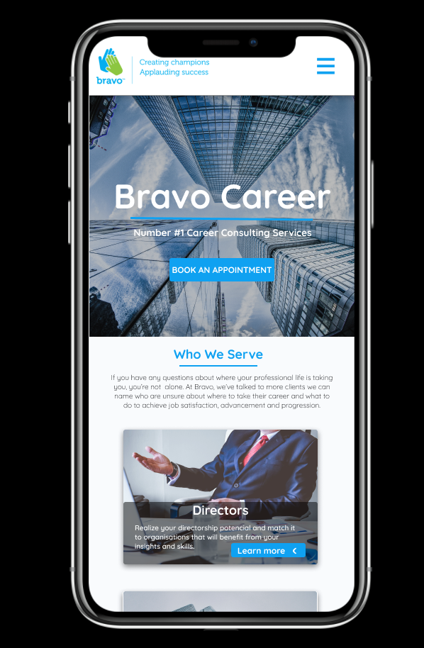

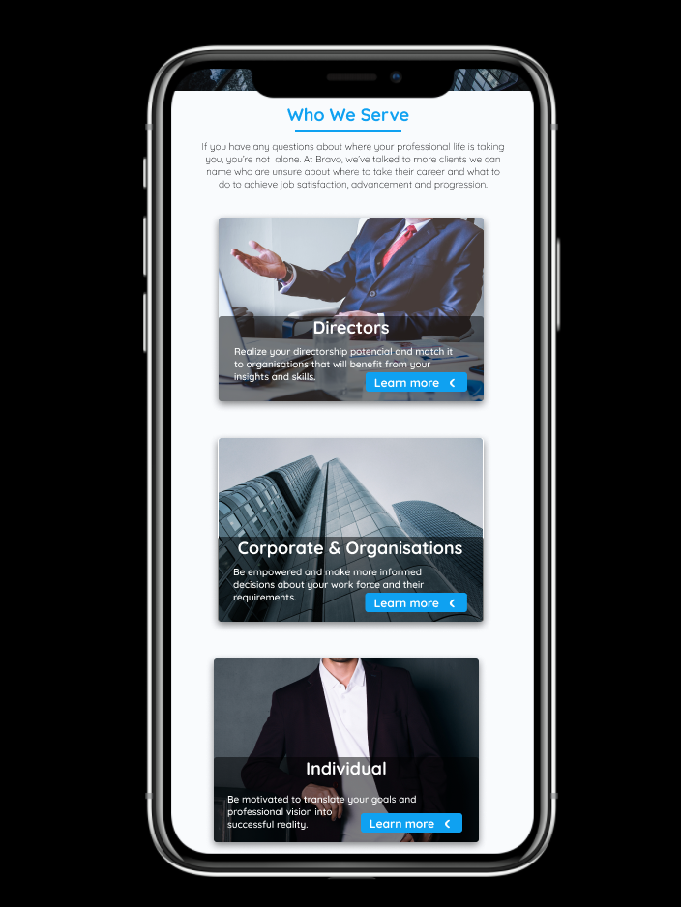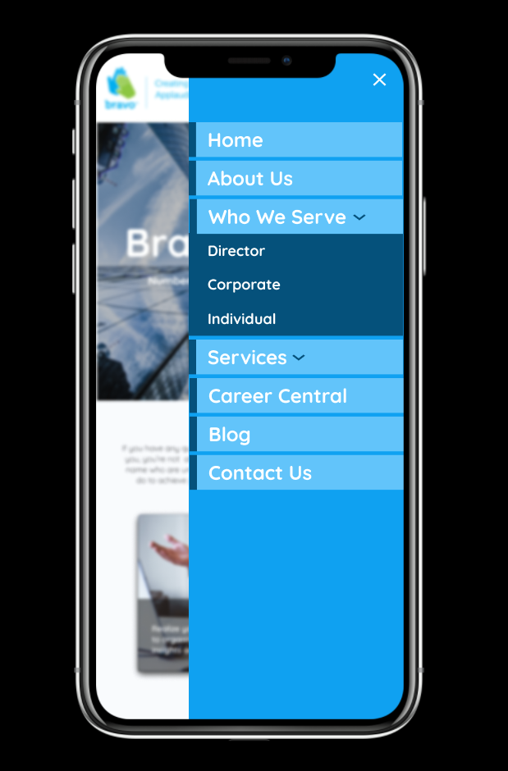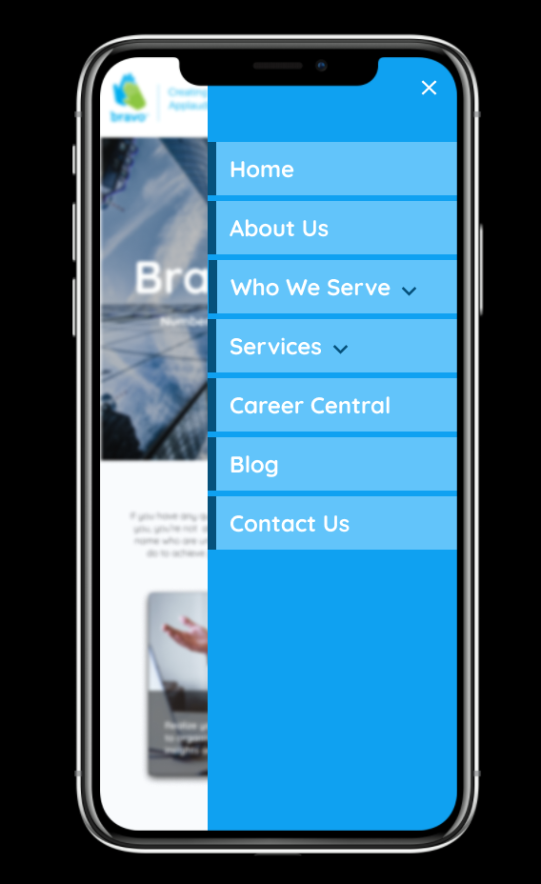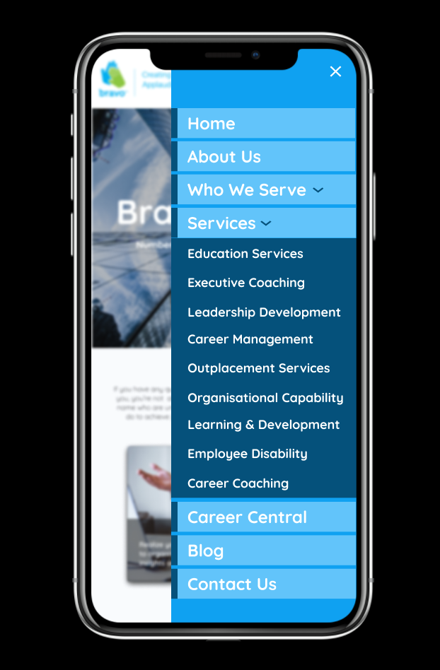

THE END